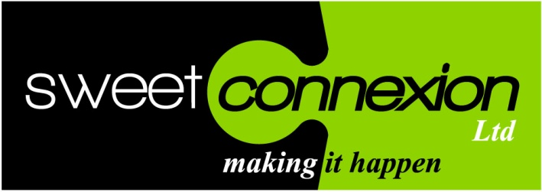

Sweet Connexion was established in April 2012 by Carl Richardson. Carl’s first experiences with licensing were as a licensee back in the late 1990’s as Marketing Director of Mr Lucky Bags, a company that had re invented kids surprise bags. Carl established a strong platform of licenses from a wide variety of licensors.

The Sweet Connexion director adds: “Before GPS there isn’t a part of London I haven’t been lost in. When I eventually found out where I was going, I remember getting a real buzz out of licensing; it really interested me, the industry was exciting and although lots has changed the buzz and excitement remains.

Through to 2010 Carl remained with the company, however, he left to take up a position with Kinnerton Confectionery as Director of The Great Character Candy Company, a division within the business dedicated to the development of licensed sugar confectionery products.

Richardson says: “My main objective was to develop a quality product range that would sell well, create impact and stand the test of time, something I am pleased to say has happened. The surprise and novelty licensed product range remains an important part of Kinnerton’s product portfolio. I still get a kick out of seeing the lines on shelves, there were a few extremely good people at Kinnerton that helped to achieve this.”

In February 2012 Carl left Kinnerton and decided to start Sweet Connexion in order to offer licensees and licensors the benefit of his experience, knowledge and contacts specialising within the area of Food and Drink.

“My epiphany came at the Spring Fair in February of this year. I arranged to meet a number of people, some new, some I had known for a long time, then it struck me that the companies I was talking to needed help to solve a variety of marketing and sales issues but they didn’t want to employ someone permanent. I pitched an interim service based on: affordability, flexibility and results, which hit the mark with two companies, one an experienced licensee, the other a fledgling licensee. Sweet Connexion then became a reality.”

From there Carl added further clients in the space of one month and Sweet Connexion Ltd began trading in April 2012.

Carl continues: “I am lucky to have found a brilliant set of clients, all as you would expect with different needs and resources. There’s something that they all do have in common and that’s a desire to be the very best they can in their field and I can help them to achieve this.”

Carl gives us a brief insight into a couple of clients that embody the ethic of brand integrity and success. The first of these is Rose Marketing. Although Rose was not totally new to licensing, they had the Vimto soft drink license for selected confectionery; they were keen to expand their licensed products and raise awareness and profile within the industry.

Sweet Connexion was appointed in April 2012 to do this, to work closely with the Managing Director on strategic planning and also add certain sales accounts to the business. Carl comments: “Rose is a dynamic business with much strength, what impresses me is their ability to react quickly, source and develop innovative products that always enhance the brand.”

Carl continues: “There’s a fire in the belly at Rose, a real passion for product development and sales, the products are first class and sales are outstanding. It was pleasing to see Rose as finalists for the Licensing Awards in their category this year for their fantastic Tango range. Also pleasing to see them win a consumer award for Vimto product. There’s a lot more to come and I am proud to be a part of their continued success.”

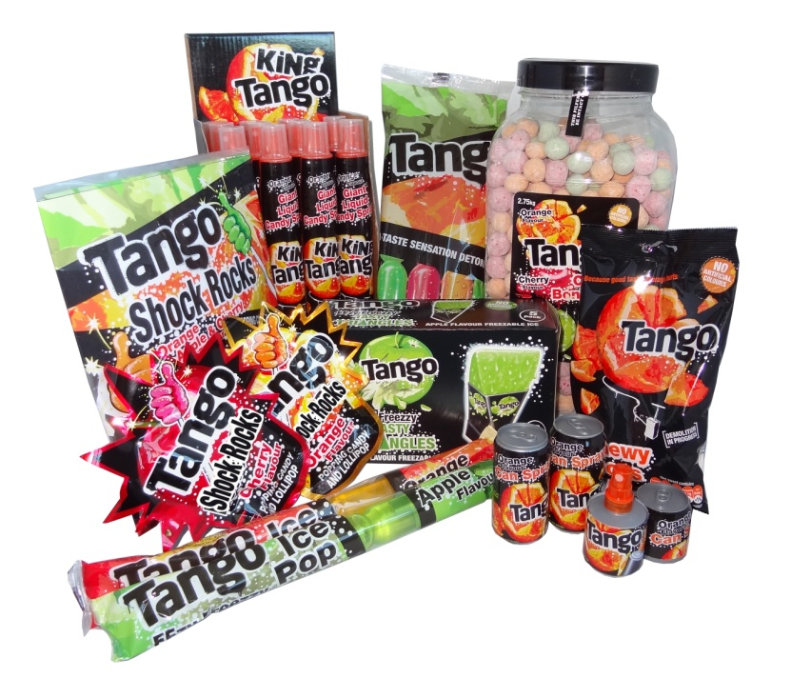

Carl is also on board with a new business (established in 2011) with strong credentials and a real opportunity to open up significant business for an innovative range of licensed character pop corn and healthier eating snacks called Savoury & Sweet.

This business has taken licenses from both Nickelodeon (Sponge Bob) and Fox (The Simpsons) to apply to their quality pop corn products in the case of Sponge Bob and their nuts and snacks in the case of The Simpsons.

Carl comments: “What impresses me about these products is their innovation and quality together with their great taste and visual appeal.” There’s a gap in the market for licensed pop corn, Savoury & Sweet have acted on this and look set to capitalise on all their hard work to ensure the product is of the highest quality. Sweet Connexion is helping drive the products into market and in the space of just a few weeks the results are encouraging.”



If you are a licensor looking to increase your penetration in Food and Drink, an existing or prospective licensee or a retailer then don’t hesitate to contact Carl at Sweet Connexion to discuss your needs?

Web site: [www.sweetconnexion.co.uk](http://www.sweetconnexion.co.uk)

Twitter: @carlsweetX

Facebook: <http://www.facebook.com/SweetConnexionLtd?ref=hl>

Tel: 0779 2049704

Email: [carl@sweetconnexion.co.uk](mailto:carl@sweetconnexion.co.uk)

Skype: carlosricho